.G. Durga Sankar Rao  
*C.S.E*  
 *Vit Ap University*Amaravati, Andhra Pradesh, India  
gdsr1613405@gmail.com

J. Suhas Raj  
*E.C.E*  
 *Vit Ap University*Amaravati, Andhra Pradesh, India  
jujjavarapusuhasrajavenger@gmail.com

# **THIRD EYE**

Prof. Eswaraiah Rayachoti  
*SCOPE*  
 *Vit Ap University*Amaravati, Andhra Pradesh, India  
eswar_507@yahoo.co.in

J. Krishna Chaitanya  
*C.S.E*  
 *Vit Ap University*Amaravati, Andhra Pradesh, India  
[jujjavarapchaitanya14@gmail.com](mailto:jujjavarapchaitanya14@gmail.com)

P. Rishikanth Reddy  
*C.S.E*  
 *Vit Ap University*Amaravati, Andhra Pradesh, India  
rishipandiri100@gmail.com

M. Raghu Pranav  
*C.S.E*  
 *Vit Ap University*Amaravati, Andhra Pradesh, India  
[pranavmaddula04@gmail.com](mailto:pranavmaddula04@gmail.com)

D. Harthik  
*C.S.E*  
 *Vit Ap University*Amaravati, Andhra Pradesh, India  
harthik78@gmail.c

# Abstract

As the excerpt from 'Neeti satakam' written by the great scholar Chanakya says –'sarvendriyanamnayanam pradhanam', which literally means, of all the senses, the sense of vision is supreme! In a world where the sense of vision is considered supreme, individuals with no vision face challenges in navigating their environment .Third eye for the blind is a project involving visually impaired human beings to confidently and independently navigate ,explore the world by means of recognizing (sensing) nearby objects using ultrasonic waves and informing the user with a beep sound or vibration and Alerting the people who are around them or obstructing their (visually impaired) path with a beep sound or red light. Third eye is a wearable cap with ultrasonic sensors and blind people don’t need to carry anything in hand like white cane while walking they can wear our invention.

Keywords-Arduino Uno, Ultra Sonic Sensor, Vibration Motor, Buzzer, LED.

# Introduction

The Third Eye project is not just a technological innovation; it's a beacon of hope for millions of visually impaired individuals who seek greater independence and inclusion in society. By addressing the limitations of traditional aids like white canes and the financial burden of guide animals, this project seeks to level the playing field

and empower the visually impaired to navigate the world with confidence [7]. At its core, the Third Eye project embodies the spirit of accessibility and equity. Its affordability ensures that those who need it the most can benefit from it, regardless of their financial resources. The wearable design (Cap) seamlessly integrates into the user's daily routine, minimizing any inconvenience or discomfort. By granting the user spatial awareness, the Third Eye not only assists in avoiding obstacles but also fosters a sense of control and self-reliance. [1]

The customization aspect is a pivotal feature, recognizing that each individual's needs and environments are unique. Whether it's indoors, outdoors, or any specific location, the Third Eye can be fine-tuned to cater precisely to the user's preferences. Through its use of ultrasonic waves, audible cues, vibrations, and LED alerts, it offers a holistic sensory experience that enhances the user's perception of their surroundings. As the World Health Organization's staggering statistic of 3.9 crore blind individuals indicates, the need for innovative and practical solutions is more urgent than ever [14]. The Third Eye project rises to this challenge with ingenuity and compassion, placing the power of autonomy and mobility directly in the hands of those who need it. By combining technology, affordability, and user-centered design, this initiative is not just about creating a product – it's about fostering a more inclusive and empathetic world. [15][12]

# Objectives

The objective of this project is **“The Third Eye”** is

* To create a wearable portable gadget for people who are blind and frequently rely on others for directions.
* To enable those who are blind or visually handicapped to walk confidently from one location to another by alerting them to potential hazards with a wearing band that emits ultrasonic waves that cause buzzing or vibrations.
* To design a portable, affordable, simple-to-manage, and effective system with many other remarkable qualities and advantages to help the blind detect impediments even when they are moving.

# Methodology

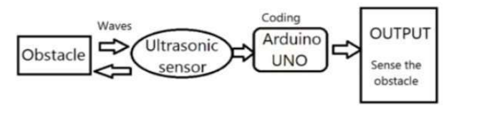

Fig.1: Methodology of Third Eye [1]

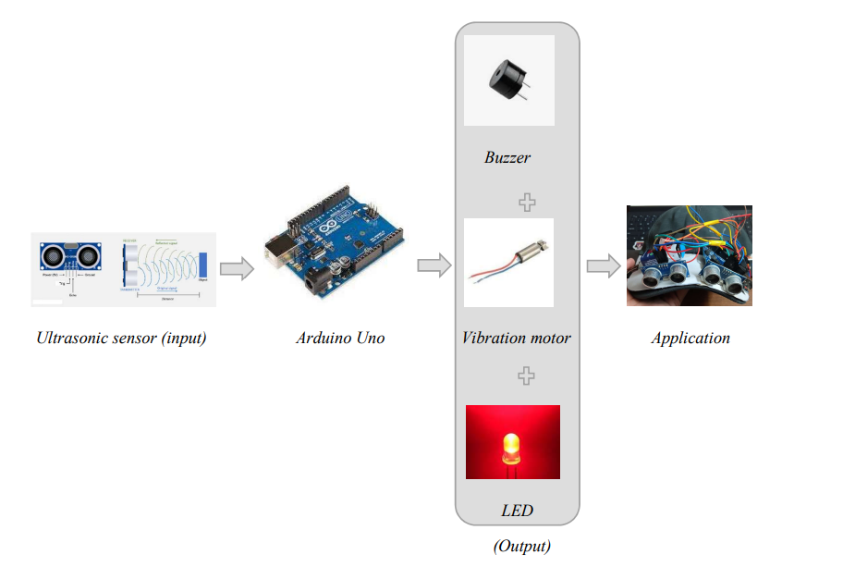

Fig.2: Block Representation of the Third eye

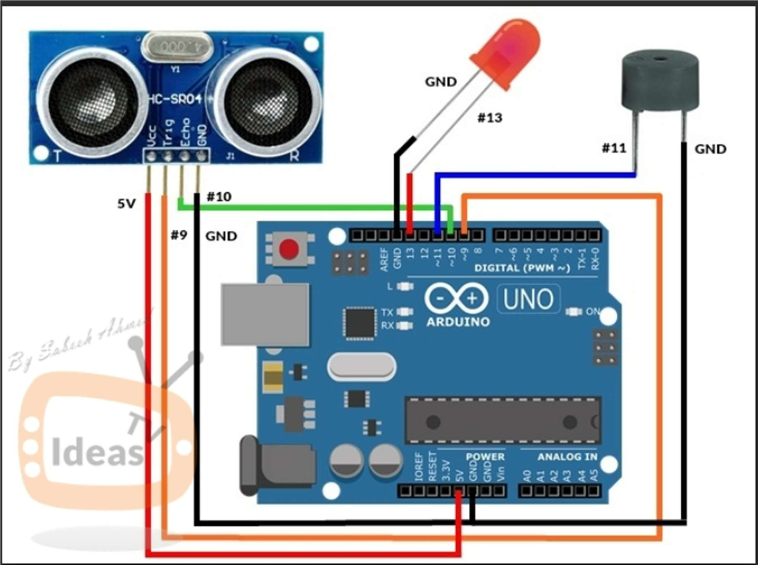[2]

Fig.3: Circuit Diagram of Third eye

Main components of Third eye of Arduino Uno, Vibration Motor, Ultra Sonic Sensor for detecting the obstacles in surroundings/in path of user and Buzzer for alerting the user about the obstacles beforehand avoiding user from facing accidents, LED for alerting the people around the user that they are obstacles for the user or users path contains obstacles, Jumpers, Switch, Battery, Clips and Cap are used to link/connect all of the device's parts to the Arduino, enabling the wearable nature of the gadget as depicted in Fig.2. The ultrasonic sensors are connected to the Arduino board in the way shown below, being sure to link the transmitter and reception pins to different digital pins. The buzzer should be attached to a digital output pin on the Arduino board before being connected. The power and ground connections should be connected to different digital pins when connecting the vibrator module to the Arduino board. Fig.3 shows how to link the Arduino Uno to the battery, and Fig.7 shows the setup after connections. The Arduino board should be updated with the given code using the Arduino IDE software. Power on the system and test the ultrasonic sensor by interrupting in front of it. Test the alarm system by verifying that the buzzer sounds and the vibrator module vibrates or not. When an obstacle is in front of the device holder, the device emits a beep sound and Red light from the led which alerts the people who are around that either they are obstructing the user’s path or there is an obstacle in user’s path. As the object's distance decreases, the sound from the gadgets increases and vibration is also initiated [8], as seen in Fig. 8. As a result, the technology makes it easier for those who are blind and lack vision to detect obstacles that are headed their way. The code can be customized to suit the specific security needs of the user, such as changing the distance length. Now you can place the system on any cap and enjoy the features of the third eye. The vibration intensity and beeping rate increase with a decrease in distance. Check the device regularly to ensure that it is functioning properly and adjust the code or hardware as needed. The complete methodology shown in Fig. 1. [3]

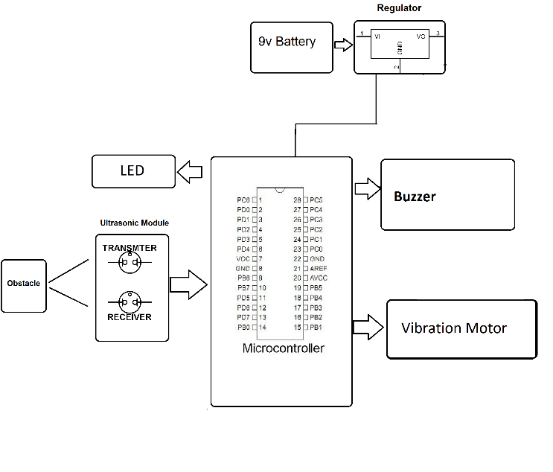

Fig.4: Flow chart

# Results

The Third Eye project represents a significant leap forward in assistive technology, offering visually impaired individuals a pathway to newfound independence and a heightened sense of awareness [7].This innovative device surpasses conventional aids, such as white canes, and presents a solution that's not only more efficient but also adaptable to the user's unique preferences. By providing users the option to wear the device as a ring or integrate it into their clothing, the Third Eye eliminates the need for carrying and manipulating additional equipment [11][2]. Its unobtrusive design makes it seamlessly blend into daily life, removing barriers and stigmas often associated with traditional aids. Its ease of use means that users can quickly become proficient with its functions, enabling them to navigate confidently without the complexities of a white cane. A striking feature is the device's customizability, allowing users to set the detection range according to their specific needs and comfort level.

Moreover, the Third Eye offers a cost-effective alternative to options like guide dogs, which come with substantial financial and logistical challenges.

The device's battery-powered design as shown in

Fig 7 ensures convenient operation, as users can replace batteries when needed, minimizing disruptions to their daily routines [6]. In essence, the Third Eye project is not just about technological advancement, it’s about granting visually impaired individuals the autonomy to move through life with dignity and freedom. It's a testament to human ingenuity and compassion, fostering inclusivity and empowerment for those who deserve it most. [3]

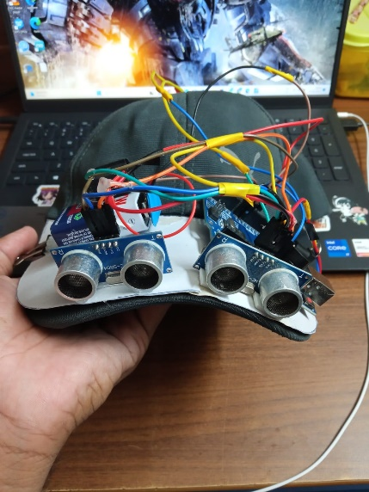 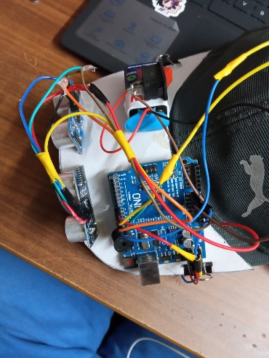

Fig 5: front view of third eye Fig 6 : connections

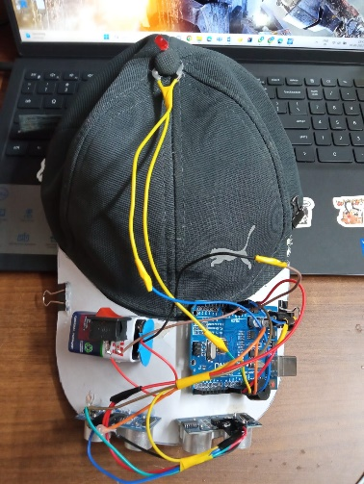 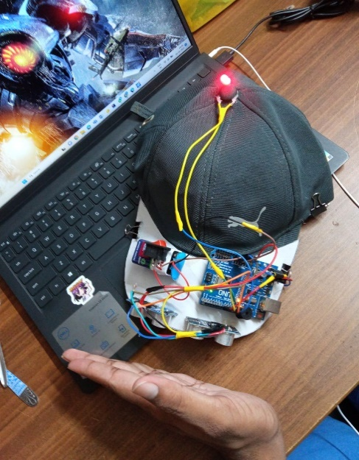

Fig 7: third eye Fig 8: working of third eye

# Graph

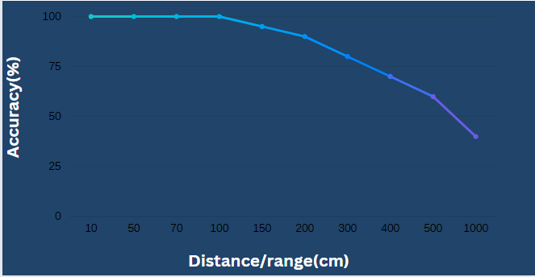

Graph.1: Range vs Accuracy of Third eye

From Graph.1, we can understand that range is inversely proportional to the accuracy of detecting obstacles. Third eye can detect the obstacle under 100 cm with 100% accuracy, so with increase in distance (range) the accuracy and efficiency of Third eye is decreased. [8]

# table

Table.1: Range vs Accuracy of Third eye

|  |  |
| --- | --- |
| Range/Distance (cm) | Accuracy (%) |
| 10 | 100 |
| 50 | 100 |
| 70 | 100 |
| 100 | 100 |
| 150 | 95 |
| 200 | 90 |
| 300 | 80 |
| 400 | 70 |
| 500 | 60 |
| 1000 | 40 |

From Table.1, we can understand that range is inversely proportional to the accuracy of detecting obstacles. Third eye can detect the obstacle under 100 cm with 100% accuracy, so with increase in distance (range) the accuracy and efficiency of Third eye is decreased. [8]

# Conclusion

The impact of the Third Eye project extends far beyond technology – it's about restoring a fundamental aspect of life that many take for granted: the freedom to move independently. By equipping blind individuals with a wearable device that emits ultrasonic waves and provides real-time feedback through vibrations and buzz sounds, this innovation transcends mere convenience. It transforms the lives of the visually impaired, granting them the ability to navigate their surroundings confidently and without relying on external aid. [7][18][19]

This wearable guiding system introduces a newfound level of safety, enabling users to detect obstacles irrespective of their size, position, or depth. Whether indoors or outdoors, users can seamlessly move from one location to another with a heightened sense of awareness and control.[11][12][16] This not only empowers them to accomplish daily tasks and engage in activities they love but also nurtures a sense of self-reliance and dignity.[7]

Through the Third Eye project, technology becomes a bridge to independence, connecting individuals with the world around them in a profound way. As they experience the newfound freedom to explore, travel, and interact with their environment, their quality of life improves exponentially. This project is not just a triumph of engineering; it's a beacon of empowerment that empowers blind individuals to step into the world with confidence and grace, enhancing their well-being and contributing to a more inclusive society for all.

# Limitations

* While obstacle detection and basic navigational assistance are capabilities of Arduino-based systems, they might not fully account for the complexity of the surroundings. They can have trouble recognizing minute features or minute differences in their environment that an individual with sight would notice.
* Power source (Battery) need to replace after certain interval of time.
* The accuracy and reliability of sensors used in the system can vary. Inaccurate or inconsistent sensor readings could lead to false alarms or missed obstacles, potentially causing accidents. [3][6]

# References

1. <https://www.ijraset.com/research-paper/aduino-based-third-eye-for-blind-people>
2. <https://www.kscst.org.in/spp/45_series/SPP45S/02_Exhibition_Projects/230_45S_BE_1135.pdf>
3. <https://ijariie.com/AdminUploadPdf/THIRD_EYES_FOR_BLIND_ijariie17476.pdf>
4. <https://www.instructables.com/THIRD-EYE-FOR-BLINDS-an-Innovative-Wearable-Techno/>
5. <https://www.irejournals.com/formatedpaper/17036251.pdf>
6. <https://www.jetir.org/papers/JETIR2205083.pdf>
7. <https://tech.hindustantimes.com/tech/news/south-korean-designer-creates-third-eye-for%02smartphone-zombies-71623030383517.html>
8. Pooja Sharma, Shimi SL, Chatterji S. A Review on Obstacle Detection and Vision, International Journal of Science and Research Technology. 2015; 4(1):1-11.
9. Bolgiano D, Meeks Jr E. A laser cane for the blind, IEEE Journal of Quantum Electronics. View at Google Scholar. 1967; 3(6):268.
10. detection and warning system for visually impaired people based on ultrasonic sensors.
11. Saha D, Pal A. A Low-cost Obstacle Avoidance System for Visually Impaired. In: Proceedings of the 2016 IEEE International Conference on Recent Trends in Electronics, Information & Communication Technology. 2016.
12. Benassi G, Palestra G, Pollini A, Cavallo F. Assistive technology for blind and visually impaired people: A survey of recent trends. In: International Journal of Advanced Robotic Systems. 2018.
13. Iliopoulos K, Tzovaras D. WALK-MAN: Wearable Sensing and Advanced Cognitive Interfaces for Monitoring Mobility Limitations. In: Proceedings of the 7th International Conference on Pervasive Technologies Related to Assistive Environments. 2014.
14. Silva M, Rodrigues P, Rodrigues N, Montezuma P. Wearable Technology for Blind People: A Systematic Review. In: Proceedings of the 10th International Conference on Pervasive Computing Technologies for Healthcare. 2016.
15. Li Y, Gong L, Wu S, Huang C. SmartCane: An electronic travel aid for the visually impaired. In: Proceedings of the 2012 IEEE/RSJ International Conference on Intelligent Robots and Systems. 2012.
16. Raman R, Datta P, Ghosal D. Visual impairment and blindness: An overview of prevalence and causes in India. In: Community Eye Health Journal. 2006.
17. Lee J, Song E. Design of an Omnidirectional Wearable Collision Avoidance Device for the Blind. In: Proceedings of the 8th International Conference on Convergence and Hybrid Information Technology. 2013.
18. Amjed Al-Fahoum S, Heba Al-Hmoud B, Ausaila Al- Fraihat A. A Smart Infrared Microcontroller-Based Blind Guidance System”, Hindawi Transactions on Active and Passive Electronic Components. 2013;3(2):1-7.